## 

## **Experiment-3**

**Student Name:** Gauri Prabhakar **UID:** 18BCS6201

**Branch:** 18AITAIML-2 **Section/Group:** B

**Semester:** 7 **Date of Performance:** 1st September, 2021

**Subject Name:** Advanced Database Management Lab **Subject Code:** CSP - 434

# Aim/Overview of the practical:

To analyze and create different types of locks.

# Task to be done:

To analyze and create different types of locks.

# Steps to be followed:

**Setting transaction isolation level for previously curated table- STUDENTS and then Inserting, Updating the**

**tuples then finally COMMITTING the values :**

# SELECT * FROM STUDENTS;

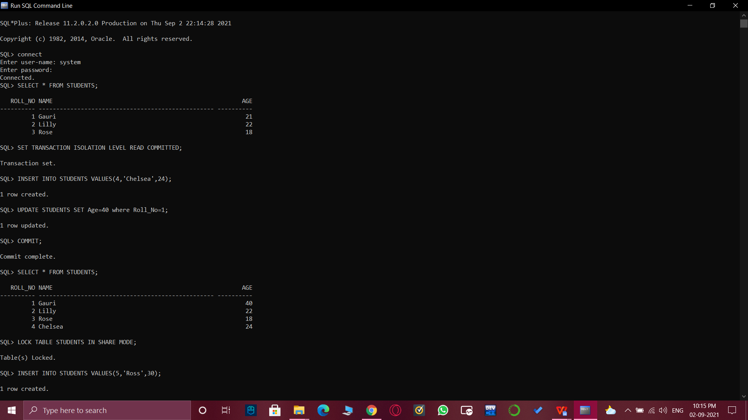

1. SET TRANSACTION ISOLATION LEVEL READ COMMITTED;

INSERT INTO STUDENTS VALUES(4,'Chelsea',24);

UPDATE STUDENTS SET Age=40 where Roll_No=1;

COMMIT;



**Displaying and then LOCKING the table in SHARE MODE:**

1. SELECT * FROM STUDENTS;

LOCK TABLE STUDENTS IN SHARE MODE;



**Again Inserting and updating tuples and finally COMMITTING them to the table and displaying the table:**

1. INSERT INTO STUDENTS VALUES(5,'Ross',30);

UPDATE STUDENTS SET Age=20 where Roll_No=5;

COMMIT;

SELECT * FROM STUDENTS;

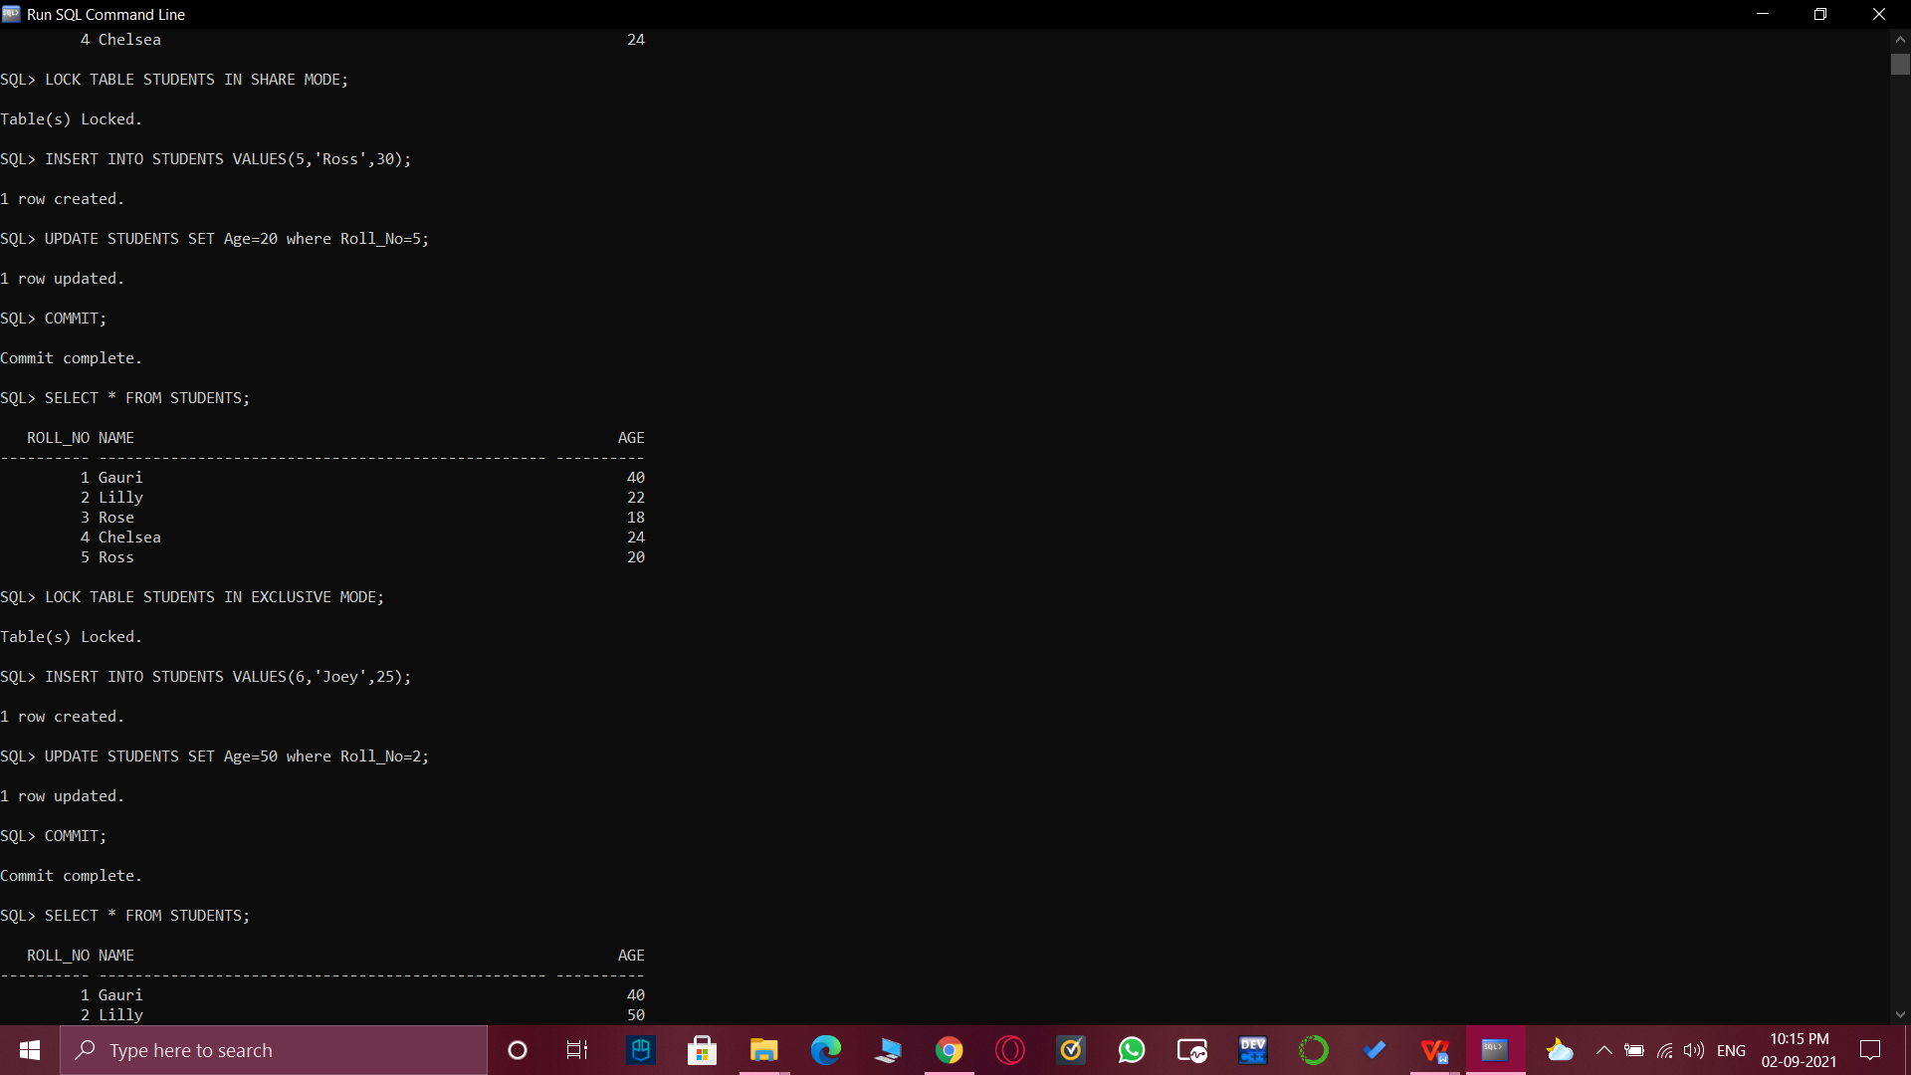

**LOCKING the table in EXCLUSIVE MODE then inserting and updating tuples and finally COMMITTING them to the table and displaying the table:**

1. LOCK TABLE STUDENTS IN EXCLUSIVE MODE;

INSERT INTO STUDENTS VALUES(6,'Joey',25);

UPDATE STUDENTS SET Age=50 where Roll_No=2;

COMMIT;

SELECT * FROM STUDENTS;



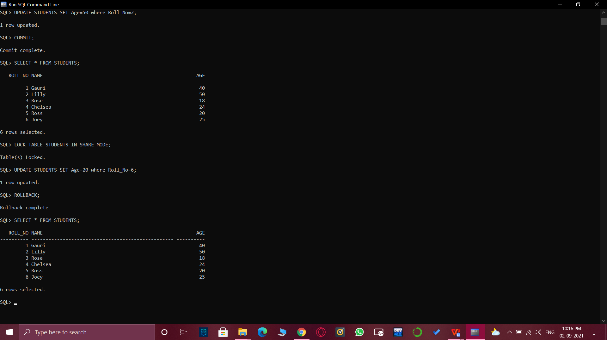

1. **LOCKING the table in SHARE MODE , updating a tuple, ROLLBACKING and displaying the table:**

LOCK TABLE STUDENTS IN SHARE MODE;

UPDATE STUDENTS SET Age=20 where Roll_No=6;

SELECT * FROM STUDENTS;



1. **Result/Output/Writing Summary:**

* Successfully implemented Locks.
* Successfully understood the functioning and importance of Locks.
* Successfully implemented TCL Commands: Commit and Rollback.
* Successfully understood the working of Transaction Isolation Level, Locks and TCL commands.

# Learning outcomes (What I have learnt):

* How to implement locks on SQL Command Line.
* TCL Commands.
* How to implement Commit and Rollback command and returned their outcomes.
* How to set Transaction Isolation Level and Locks on a table.

**Evaluation Grid (To be created as per the SOP and Assessment guidelines by the faculty):**

|  |  |  |  |
| --- | --- | --- | --- |
| Sr. No. | Parameters | Marks Obtained | Maximum Marks |
| 1. |  |  |  |
| 2. |  |  |  |
| 3. |  |  |  |